Project Planning Phase
Project Planning Template (Product Backlog, Sprint Planning, Stories, Story points)
Date | 21 October 2026
Team ID | SWUID2026403023
Team Members | Individual project (single member)
Project Name | StaffSync
Maximum Marks
Document Version | v1.2 (revised 27 October 2026; originally issued 21 October 2026 as v1.0)

Product Backlog, Sprint Schedule, and Estimation
Sprint | Functional Requirement (Epic) | User Story Number | User Story / Task | Story Points | Priority | Team Members
Sprint-1 | Project Setup & Authentication | USN-1 | As a developer, I set up the MERN project structure, environment variables (.env.example), MongoDB connection and the HR seed script. | 3 | High | Project owner
Sprint-1 | Project Setup & Authentication | USN-2 | As a user, I can log in securely using JWT (HR, Manager, Employee roles), log out, change my password, and must change a temporary password at first login. | 5 | High | Project owner
Sprint-1 | Project Setup & Authentication | USN-3 | As a user, I can only access pages and APIs permitted for my role. | 4 | High | Project owner
Sprint-1 | Employee Management | USN-4 | As HR, I can add, edit, view, search and deactivate employee records (no permanent deletion). | 5 | High | Project owner
Sprint-1 | Employee Management | USN-5 | As an employee, I can view and update my personal details. | 3 | Medium | Project owner
Sprint-2 | Leave Management | USN-6 | As an employee, I can apply for leave (validated dates, no overlaps, balance check), cancel a pending request and see my history and status. | 5 | High | Project owner
Sprint-2 | Leave Management | USN-7 | As a manager, I can approve or reject my direct reports' leave requests (not my own) and view my team's leave calendar. | 5 | High | Project owner
Sprint-2 | Leave Management | USN-8 | As HR, I can view all leave requests and approve or reject any pending one except my own (another HR user decides an HR user's own request). | 4 | High | Project owner
Sprint-2 | Attendance Management | USN-9 | As an employee, I can check in and out once per day; duplicates are blocked. | 4 | High | Project owner
Sprint-2 | Attendance Management | USN-10 | As an employee, I can view my attendance history. | 2 | Medium | Project owner
Sprint-3 | Attendance Management | USN-11 | As HR, I can view attendance of all employees, filter by date and employee, and correct a record with a reason. | 5 | Medium | Project owner
Sprint-3 | Announcements & News | USN-12 | As HR, I can post, edit and delete announcements with publish and expiry dates. | 5 | High | Project owner
Sprint-3 | Announcements & News | USN-13 | As an employee, I can view the latest announcements and news. | 3 | Medium | Project owner
Sprint-3 | Training & Development | USN-14 | As a manager, I can create training programs with a deadline, assign them to my direct reports and track progress. | 7 | High | Project owner
Sprint-4 | Training & Development | USN-15 | As an employee, I can view my assigned trainings and move their status (Not Started, In Progress, Completed). | 4 | Medium | Project owner
Sprint-4 | Frontend Dashboards | USN-16 | As a user, I see a role-based dashboard with a responsive Bootstrap UI. | 6 | High | Project owner
Sprint-4 | Frontend Dashboards | USN-17 | As a user, I get clear validation messages and error handling on all forms. | 3 | Medium | Project owner
Sprint-4 | Project Execution | USN-18 | As a developer, I test all APIs in Postman and prepare the UAT accounts, test data and test cases. | 6 | High | Project owner
Sprint-4 | Project Execution | USN-19 | As a developer, I deploy the app and publish the demo and GitHub links. | 1 | High | Project owner

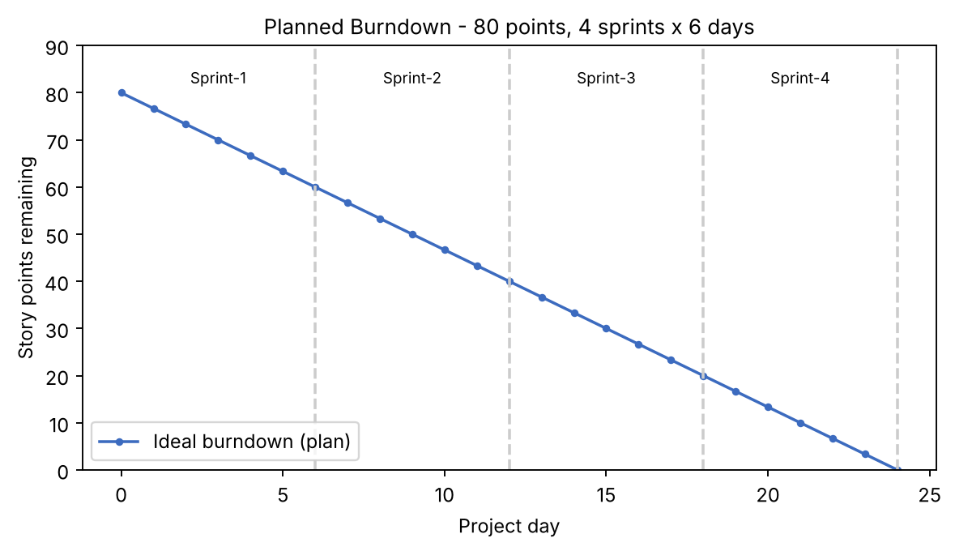
Sprint Goals and Dependencies
Sprint | Goal | Depends on | Done when | Status
Sprint-1 | Working project skeleton, login with roles, employee management | - | A user can log in as HR / Manager / Employee, HR can manage employees, the seed script runs, and role checks are tested in Postman | Planned
Sprint-2 | Leave workflow and attendance capture | Sprint-1 (users, employees, auth middleware) | Leave can be applied for and decided under FR-3 rules; check-in / check-out works once per day | Planned
Sprint-3 | HR attendance view, announcements, training creation | Sprint-2 (attendance data); Sprint-1 (employee-manager links) | HR can filter attendance; announcements visible to all; manager can assign training | Planned
Sprint-4 | Employee training view, dashboards, validation, API testing, UAT preparation and deployment | Sprints 1-3 | Postman collection covers every endpoint; UAT accounts, data and test cases (TC-001 to TC-044) are ready; the app is deployed and links are verified. UAT execution follows in the 15-20 November UAT window. | Planned

Revision History
Version | Date | Summary of changes
v1.0 | 21 October 2026 | Initial issue.
v1.1 | 23 October 2026 | Story texts aligned with the requirements (login, logout, password, team calendar, HR own-leave rule, attendance correction, training progress); USN-18 limited to API testing and UAT preparation so UAT (15-20 Nov) no longer conflicts with the Sprint-4 end date.
v1.2 | 27 October 2026 | Aligned the project overview and role/module descriptions with the current StaffSync stack and demo deployment; retained detailed design notes and planned-vs-actual distinctions.

